**QID :** 151 - The sum of a proper fraction and its reciprocal is 61/30. Find the fraction.

**Options:**

1) 1/3

2) 5/6

3) 3/10

4) 3/5

**Correct Answer:** 5/6

**QID :** 152 - Sum of four consecutive odd numbers is 208. Find the largest number.

**Options:**

1) 55

2) 57

3) 59

4) 61

**Correct Answer:** 55

**QID :** 153 -

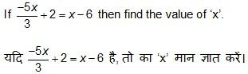

**Options:**

1) 1

2) 2

3) 3

4) 4

**Correct Answer:** 3

**QID :** 154 - Divya and Kriti have total 46 candies. If Divya has 10 candies more than kriti, then find the total number of candies Divya have?

**Options:**

1) 20

2) 24

3) 28

4) 32

**Correct Answer:** 28

**QID :** 155 -

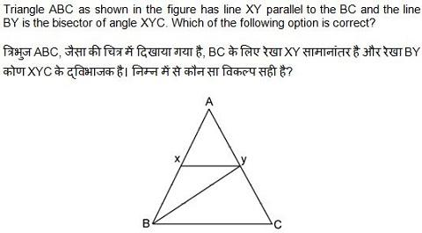

**Options:**

1) BC=XY

2) BC=YC

3) BC=BY

4) XY=BX

**Correct Answer:** BC=YC

**QID :** 156 - Analyze the figure shown below in which DE || BC and the other dimensions are as follows: AD=3 cm, BD=4 cm, AE=4.4 cm and DE=6 cm. Calculate the length (in cm) of BC.

**Options:**

1) 6

2) 8

3) 12

4) 14

**Correct Answer:** No Correct Answer ( Benefit to all )

**QID :** 157 - Two numbers are more than the third number by 16.25% and 55% respectively. First number is what percentage of the second number?

**Options:**

1) 85

2) 81.5

3) 75

4) 61.25

**Correct Answer:** 75

**QID :** 158 - If u : v = v : w, then what is the value of u4 : v4?

**Options:**

1) u2 : wv

2) u2 : w2

3) u2 v : w3

4) u : w

**Correct Answer:** u2 : w2

**QID :** 159 - R and S started a business by investing Rs 165000 and Rs 195000 respectively for the same period of time. If R’s share in the profit earned by them is Rs 11000, then what is the total profit (in Rs) earned by both of them together?

**Options:**

1) 22000

2) 40000

3) 26000

4) 24000

**Correct Answer:** 24000

**QID :** 160 - The average of 12 numbers is 35. If four numbers 20, 27, 15 and 29 are removed then what will be the average of remaining numbers?

**Options:**

1) 41.125

2) 49.5

3) 52.5

4) 38.375

**Correct Answer:** 41.125

**QID :** 161 - What is the difference (in Rs) between compound interest (compounded annually) and simple interest for 3 years on a principal of Rs 3000 at the annual rate of 20%?

**Options:**

1) 464

2) 384

3) 356

4) 424

**Correct Answer:** 384

**QID :** 162 - A dishonest shopkeeper uses a weight of 850 gm instead of 1 kg and sells rice on its cost price. What will be his profit percentage on selling 5 kg rice?

**Options:**

1) 18.24

2) 17.65

3) 15

4) 13.04

**Correct Answer:** 17.65

**QID :** 163 - A fan is sold at a discount of 37.5%. If the marked price of the fan is Rs 7200, then what is the selling price (in Rs) of the fan?

**Options:**

1) 4500

2) 4350

3) 5240

4) 5120

**Correct Answer:** 4500

**QID :** 164 -

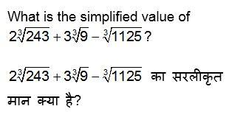

**Options:**

1)



2)



3)



4)



**Correct Answer:**

**QID :** 165 - 24 men can repair a road in 50 days. If they are joined by 16 more men, then in how much time (in days) the road can be repaired?

**Options:**

1) 28

2) 25

3) 32

4) 30

**Correct Answer:** 30

**QID :** 166 - Two motorcycles are moving towards each other with the speeds of 38 km/hr and 88 km/hr respectively. One second before the collision what will be the distance (in metres) between the two motorcycles?

**Options:**

1) 42

2) 40

3) 34

4) 35

**Correct Answer:** 35

**QID :** 167 -

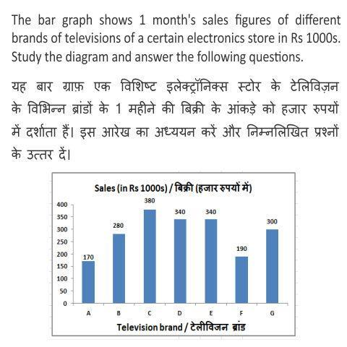

Sales of which television brand were the second lowest?

**Options:**

1) A

2) C

3) G

4) F

**Correct Answer:** F

**QID :** 168 -



What is the ratio of sales of brand E to that of brand A?

**Options:**

1) 1 : 2

2) 2 : 1

3) 4 : 1

4) 1 : 4

**Correct Answer:** 2 : 1

**QID :** 169 -



Sales of brand B was lesser than that of brand G by ________.

**Options:**

1) 3.75%

2) 6.67%

3) 7.14%

4) 5.25%

**Correct Answer:** 6.67%

**QID :** 170 -



If the sales figures are exclusive of tax then at the rate of 12% tax how much is the tax to be paid (in Rs) on the sales of all the 7 brands of televisions?

**Options:**

1) 240000

2) 24000

3) 420000

4) 42000

**Correct Answer:** 240000

**QID :** 171 - The area and the length of one of the diagonals of a rhombus is 60 cm2 and 8 cm respectively. Find the length of its other diagonal (in cm).

**Options:**

1) 7.5

2) 30

3) 22.5

4) 15

**Correct Answer:** 15

**QID :** 172 - Find the area (in cm2) of a semi-circle of radius 7 cm.

**Options:**

1) 154

2) 21

3) 42

4) 77

**Correct Answer:** 77

**QID :** 173 - Find the total surface area (in cm2) of a cube of side 3.5 cm.

**Options:**

1) 91.7

2) 64

3) 88

4) 73.5

**Correct Answer:** 73.5

**QID :** 174 - What is the value of ( 1/√3 + cot600) ?

**Options:**

1) 3√3/2

2) 7/2√3

3) (4+√3)/2√3

4) 2/√3

**Correct Answer:** 2/√3

**QID :** 175 - ∆ABC is right angled at B. If cotA = 7/24, then what is the value of cosecC ?

**Options:**

1) 7/25

2) 25/7

3) 24/7

4) 7/24

**Correct Answer:** 25/7

## 